TERRAFORM TASK-1

Q: Deploy a simple web application using AWS code commit, code build and deploy & access via browser and automate via codepipeline.

OUTPUT: Initially checked if terraform, AWS CLI are installed and verified version in CLI

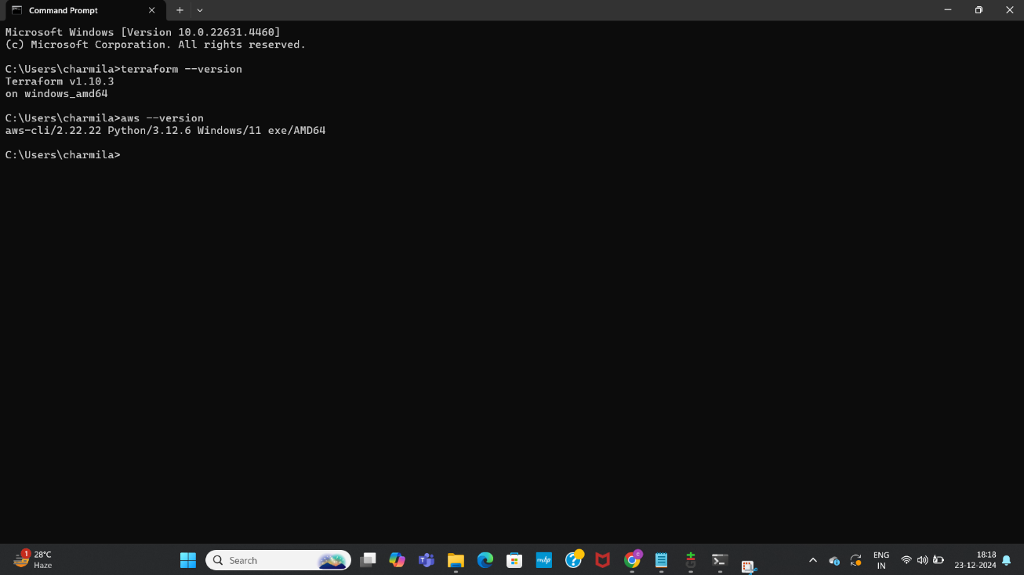

Created IAM user, fetched secret key, access key, output format and default region

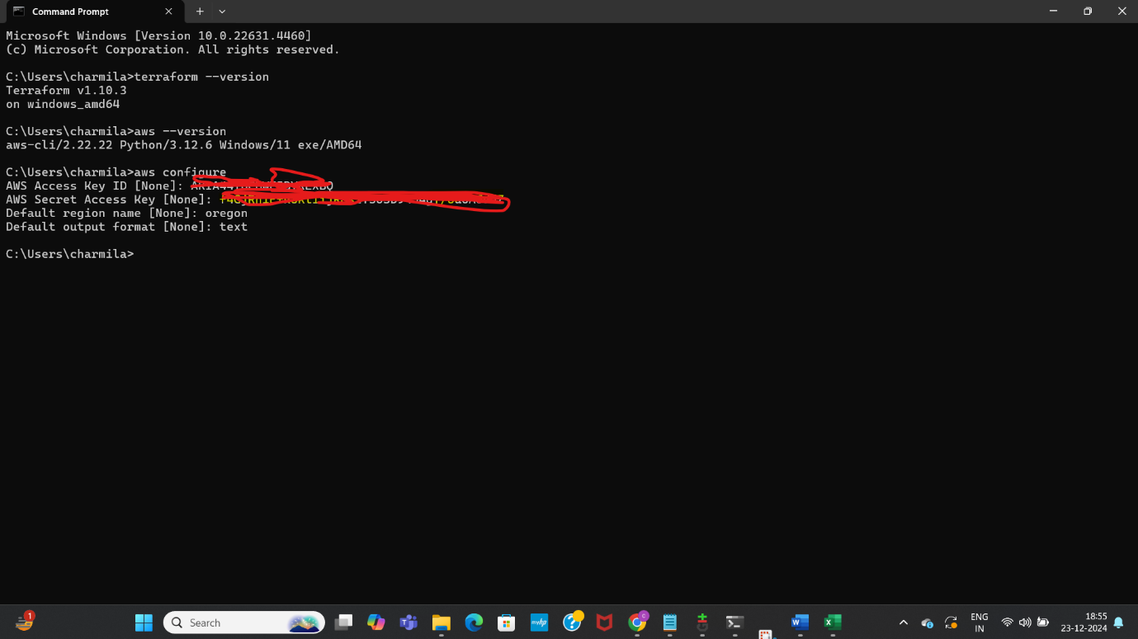

Made a directory terraform, created a terraform file with config code

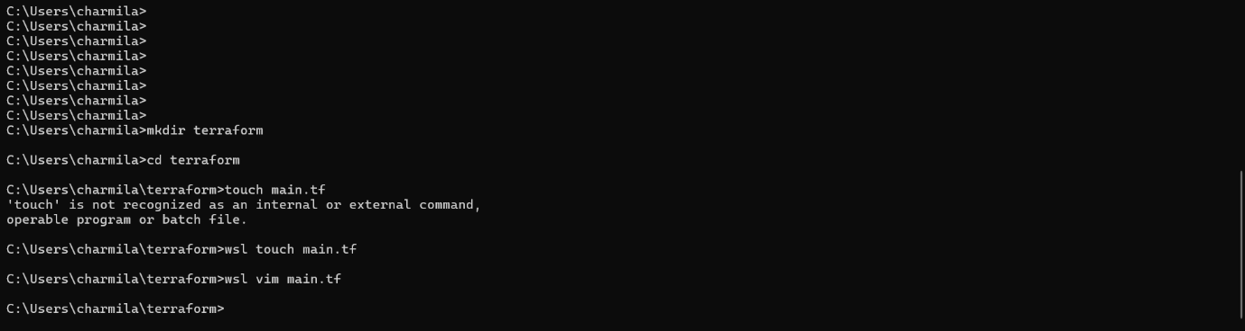

Below is the code in terraform file

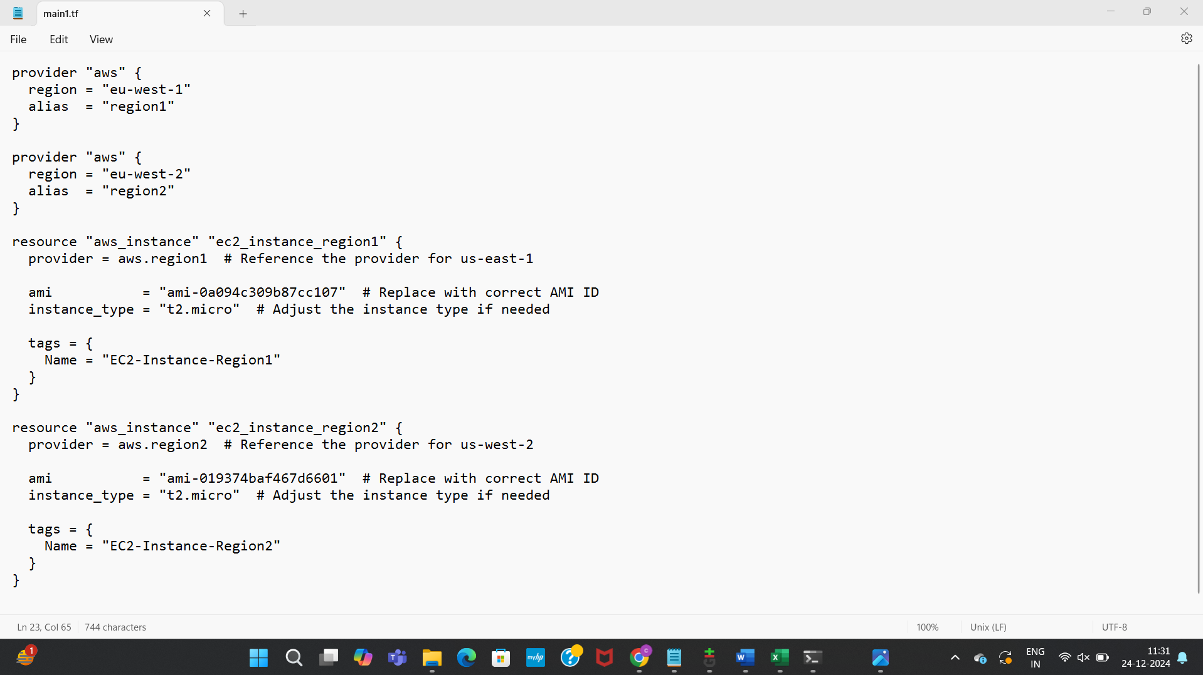

Ran commands to initialize terraform

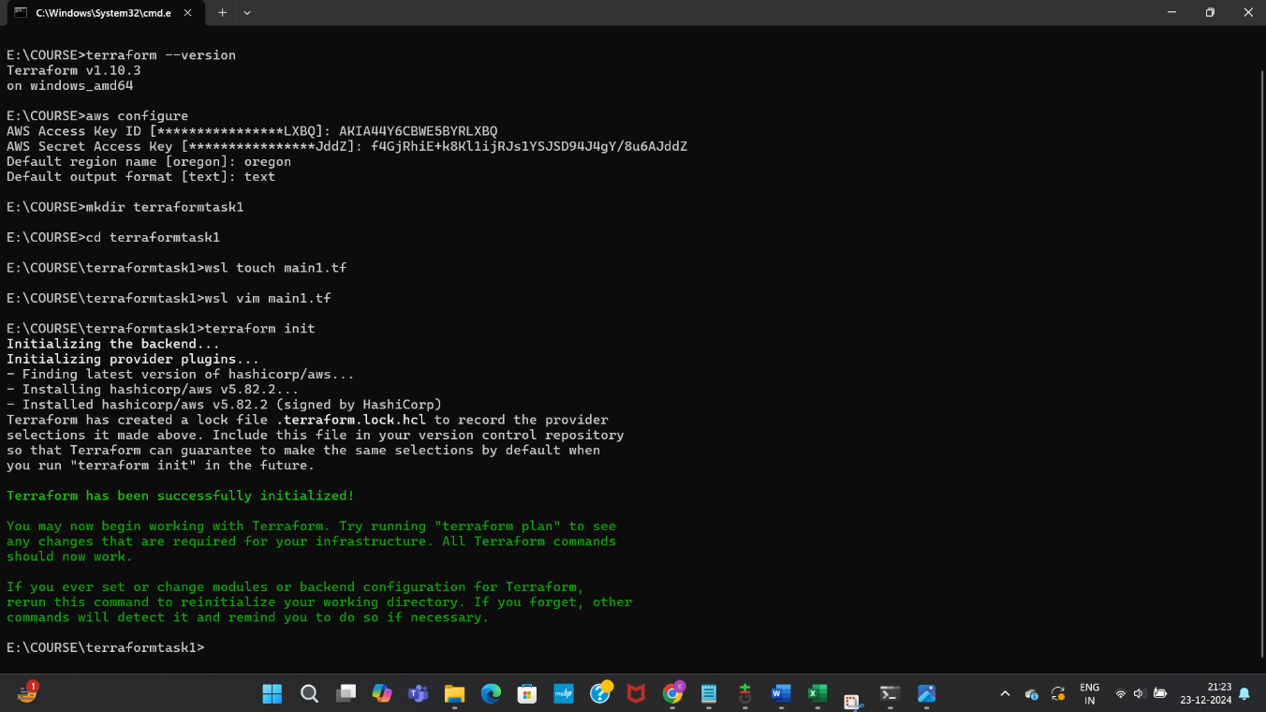

Checked validation

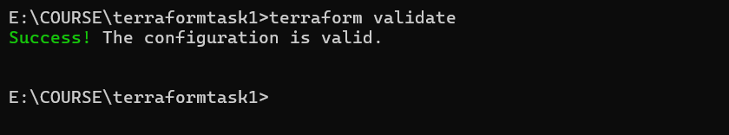

Created execution plan

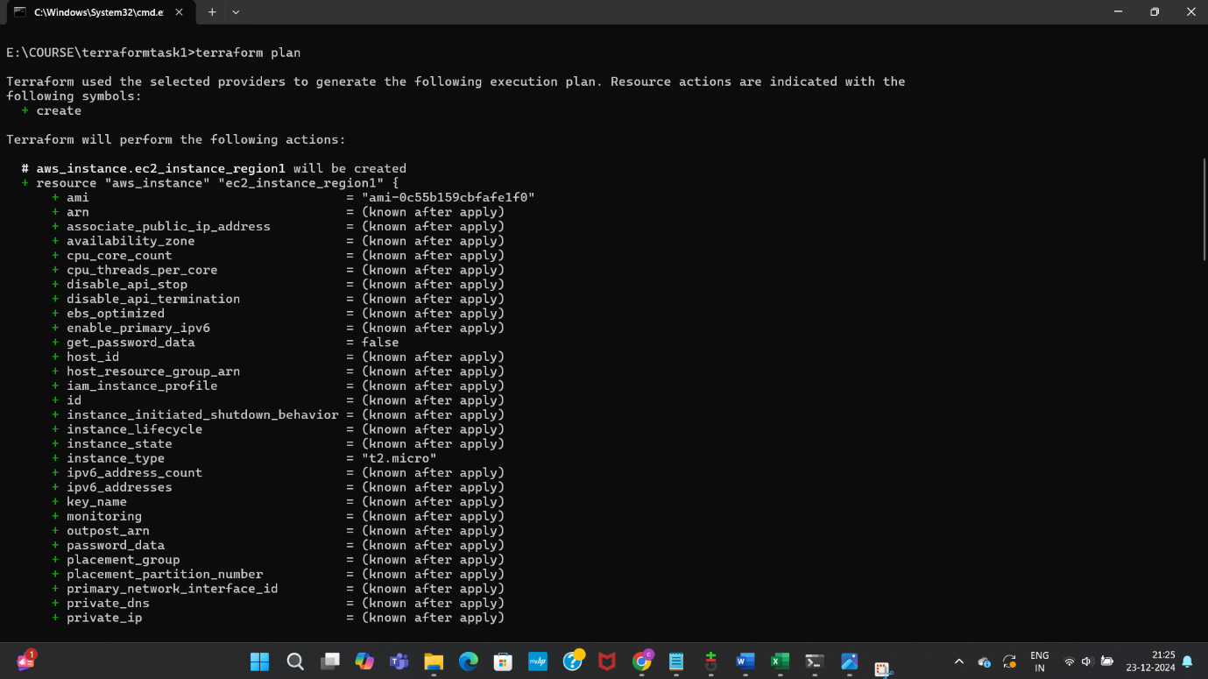

Launched two EC2 instances in different regions using this same terraform configuration file

